|  |  |
| --- | --- |
|  | **COMSATS University Islamabad**  **Sahiwal, Pakistan** |

**EVENTIVO**

By

**Tariq Hussain** **CIIT/FA17-BSE-060/SWL**

**Waheed Khadim Hussain** **CIIT/FA17-BSE-062/SWL**

**Hafiz M. Asif Afzal CIIT/FA17-BSE-075/SWL**

***Supervisor***

***Mr. Zafar Iqbal Roy***

***Bachelor of Science in Software Engineering (2017-2021)***

**The** **candidate confirms that the work submitted is their own and appropriate credit has been given where reference has been made to the work of others.**

|  |  |
| --- | --- |
|  | **COMSATS University Islamabad,**  **Sahiwal, Pakistan** |

**EVENTIVO**

**A project presented to**

**COMSATS University Islamabad, Sahiwal Campus**

In partial fulfillment

**of the requirement for the degree of**

***Bachelor of Science in Software Engineering (2017-2021)***

By

**Tariq Hussain** **CIIT/FA17-BSE-060/SWL**

**Waheed Khadim Hussain** **CIIT/FA17-BSE-062/SWL**

**Hafiz M. Asif Afzal CIIT/FA17-BSE-075/SWL**

**DECLARATION**

We hereby declare that this application, neither whole nor as a part has been copied out from any source. It is further declared that we have developed this software and accompanied report entirely on the basis of our personal efforts. If any part of this project is proved to be copied out from any source or found to be reproduction of some other. We will stand by the consequences. No Portion of the work presented has been submitted of any application for any other degree or qualification of this or any other university or institute of learning.

Tariq Hussain Waheed Khadim Hussain Hafiz M. Asif Afzal

--------------------------- --------------------------- ---------------------------

CERTIFICATE OF APPROVAL

It is to certify that the Final Year Project of BS (Computer Science) **“EVENTIVO”** was developed by **“Tariq Hussain (CIIT/FA17-BSE-060/SWL), Waheed Khadim Hussain (CIIT/FA17-BSE-062/SWL) and Hafiz M. Asif Afzal (CIIT/FA17-BSE-075/SWL)**” under the supervision of **“Mr. Zafar Iqbal Roy”** and that in their opinion it is fully adequate, in scope and quality for Bachelors of Science in Computer Science.

---------------------------------------

**Supervisor**

**Mr. Zafar Iqbal Roy**

---------------------------------------

**External Examiner**

---------------------------------------

**Head of Department**

**Dr. Javed Farzund**

**(Department of Computer Science)**

**EXECUTIVE SUMMARY**

In practice, identification of criminal in Malaysia is done through thumbprint identification. However, this type

An Eventivo application provides the searching facilities based on various factor. This android app will provide an interface for searching wedding halls and marquees. This application can be used to check the availability of venue on a particular day, so we do not need to go and visit different places manually. User can compare two or more venues for his/her ease. The system will give suggestions according to the budget and number of attendees. The user can pay online with more security. The user can book other essentials for function like DJ, food etc. through this application. The user can save time and money to search for hall. Information of individual’s booking is stored in database. Owner of the venue can insert his details from his account, he can edit his information and update if needed. Eventivo is a much-needed system in this busy world. Due to lack of time people face many difficulties in booking venue and other essentials for a function. This system will provide a place for users to book their requirements of function online without much headache and less time consumption. As everything these days is being online so this system will be a fruitful and beneficial addition in this online world. The user can easily check the nearby and recommended venues in a defined budget. Many people want to book the venue and other essentials with less or no effort these days, but people have to visit different banquets and marquees individually and collect the quotations. Some people become much lazy that they delay the booking process because manually booking consumes too much time and effort involved. People don’t want to go out. People want easiness in their lives so we come up with the idea to ease the people and community. For the marriages and events, we must book marriage halls or marques or other lawn etc. and also need about all the essentials that are compulsory in the event like food, music band system, decoration, photography etc. so we designed a Place Booking application that provide all these services and our community will get benefit of it. The venue booking application provides user the searching facilities based on various factors. This android application will provide the functionality for searching wedding halls and marquees for the events.

**Acknowledgement**

All praise is to Almighty ALLAH who bestowed upon us a minute portion of His boundless knowledge by virtue of which we were able to accomplish this challenging task. We are greatly indebted to our project supervisor “Mr. Zafar Iqbal Roy”. Without their personal supervision, advice and valuable guidance, completion of this project would have been doubtful. We are deeply indebted to them for their encouragement and continual help during this work. And we are also thankful to our parents and family who have been a constant source of encouragement for us and brought us the values of honesty & hard work.

Tariq Hussain Waheed Khadim Hussain Hafiz M. Asif Afzal

--------------------------- --------------------------- ---------------------------

ABBREVIATIONS

|  |  |
| --- | --- |
| **SRS** | Software Require Specification |
| **ML** | Machine Learning |
| **FPR** | Fundamentals of Pattern Recognition |
| ICP | Introduction to Programming |
| **OOP** | Object Oriented Programming |
| **DB** | Database System |
| **SE** | Software Engineering |
| **GUI** | Graphical User Interface |

Table of Contents

1 Introduction 2

1.1 Relevance to Course Modules 3

1.1.1. Object Oriented Programming (OOP) 3

1.1.2. Software Engineering (SE) 3

1.1.3. Database System (DB) 3

1.1.4. Machine Learning 3

1.2 Project Background 3

1.3 Literature Review 4

1.4 Analysis from Literature Review 4

1.5 Methodology and Software Lifecycle for This Project 5

1.6 Rationale behind Selected Methodology 6

2 Problem Definition 9

2.1 Problem Statement 9

2.2 Proposed Solution 10

2.3 Deliverables and Development Requirements 10

2.3.1. Hardware Requirements 10

2.3.2. Software Requirements 10

2.4 Current Systems 11

2.4.1. VenueHub.pk 11

2.4.2. VenuBazaar.pk 11

3 Requirement Analysis 13

3.1 Requirements Gathering Techniques 13

3.2 Functional Requirements 13

3.3 Non-Functional Requirements 15

3.3.1. Security Requirements 15

3.3.2. Maintainability 15

3.3.3. Availability 15

3.3.4. Performance 15

3.3.5. Portability 15

3.3.6. Scalability 15

3.4 Use Cases Diagram(s) 16

3.4.1. System Level Use Case 17

3.5 Use case description 18

4 Design and Architecture 24

4.1 Architectural design: 24

4.2 Data design 26

4.3 Data dictionary 26

4.4 Design models 26

4.4.1. Class Diagram 26

4.4.2. Sequence Diagram 28

4.4.3. Activity Diagram 31

4.4.4. Dataflow Diagram 33

5 Implementation 35

5.1 Algorithm and implementation 35

5.2 User Interface 35

6 Testing and Evaluation 40

6.1 Manual Testing 40

7 Conclusion and Future Work 45

7.1 Conclusion 45

7.2 Future Work 45

References 46

List of Tables

Table 1: Tools and Technologies 7

Table 2: Search Venue 18

Table 3: Take Suggestions 18

Table 4: Do Comparison 19

Table 5: Chat with seller 19

Table 6: Book Essentials 20

Table 7: Feedback 20

Table 8: Make Payment 21

Table 9: Manage Booking 21

Table 10: Manage Venue Details 22

Table 11: Unit Testing 1 40

Table 12: Unit Testing 2 41

Table 13: Unit Testing 3 41

Table 14:Unit Testing 4 42

Table 15:Functional Testing 1 42

**List of Figures**

Figure 1: Incremental Model 6

Figure 2: System Level Use case 17

Figure 3: System Level Use Case 17

Figure 4: Architecture Diagram 25

Figure 5: Class Diagram 27

Figure 6: Sequence Diagram (User) 28

Figure 7:Sequence Diagram (Manager) 29

Figure 8: Sequence Diagram (Admin) 30

Figure 9: Activity Diagram (User) 31

Figure 10: Activity Diagram (Manager) 32

Figure 11: Data Flow Diagram 33

Figure 12: Splash Screen 36

Figure 13:Home Screen 36

Figure 14: Sign Up 37

Figure 15: Sign in 37

Figure 16: Add Venue 38

Figure 17:Manage essentials 38

CHAPTER NO: 01

INTRODUCTION

# Introduction

We all know that every business is going to shifted on online platforms people like to deal with any person or company about anything or any product by just sitting at their home. Many people want to book the venue and other essentials will less or no effort these days, but people have to visit different banquets and marquees individually and collect the quotations. Some people become much lazy that they delay the booking process because manually booking consumes too much time and effort involved. People don’t want to go out. People want easiness in their lives so we come up with the idea to ease the people and community. For the marriages and events, we must book marriage halls or marques or other lawn etc. and also need about all the essentials that are compulsory in the event like food, music band system, decoration, photography etc. so we designed a Place Booking application that provide all necessary services and our community will get benefit from it. The venue booking application provides user the searching facilities based on various factors. This android application will provide the functionality for searching wedding halls and marquees for the events. This application can be used to check the availability of venue on particular day, so we do not need to go and visit different places manually and just book our desired venue by sitting at home using our smartphone. User can compare two or more venues for his/her ease to get suggestions that which one is best for him/her. The system will give suggestions according to the budget and number of attendees. The user can also book other essentials for function like DJ (sound system), food, decoration etc. through this application. The application will save both the time and money of people to search for hall. Information of individual’s booking is stored in database. Owner of the venue can insert his details from his account, he can edit his information and update if needed. The user can book all the function’s essential without any effort. User can also give the feedback and rate about booking place that will help others to get views about that venue. Through EVENTIVO application, the user can book all the function’s essential without any effort by sitting at home or any location. User can be able to compare different venues by using this application. The system will give suggestions according to the budget and number of people so user can view them according to his needs. The seller will be able to get more customers by creating the venue’s profile and can add all details about venue on profile. It’s a great work for community without any boundary and can get complete access on food ordering, sitting capacity and all other arrangements on a single application.

## Relevance to Course Modules

We developed this system under the guidelines of some of these courses are as follows:

### Object Oriented Programming (OOP)

Using the concepts of OOP approach in programming pattern and coding design we implemented our project.

### Software Engineering (SE)

This course helped us to evaluate our development methodologies which are used in our project.

### Database System (DB)

In this project we used normalized database system to remove dependency and for efficient outcome. We have used database to store and maintain records.

### Machine Learning

This course helped us to Implement machine learning algorithms for recommendation which are used in our project.

## Project Background

In this modern age everyone wants all work online by sitting at home so to book Halls, Banquets and other essentials for any event (birthday, Wedding, Engagement etc.) manually is very time-consuming task for most of the people. They have to go to collect all correct information through manual visits. Due to much time consumption in manual visits to each venue, people lower their choices and visit the main ones only and leaves the better ones just because of travelling and time consumption. This application will provide these services on one click.

## Literature Review

Many people want to book the venue and other essentials will less or no effort these days, but people have to visit different banquets and marquees individually and collect the quotations. Some people become much lazy that they delay the booking process because manually booking consumes too much time and effort involved. It is also very difficult to compare two or more venues manually without having proper reviews of their previous clients. EVENTIVO is a much-needed system in this busy world. Due to lack of time people face many difficulties in booking avenue and other essentials for a function. This system will provide a place for users to book their requirements of function online without much headache and less time consumption. As everything these days is being online so this system will be a fruitful and beneficial addition in this online world. The user can easily check the nearby and recommended venues in a defined budget

This system will provide the searching facilities based on various factor. This android app will provide an interface for searching wedding halls and marquees. This application can be used to check the availability of venue on particular day, so we do not need to go and visit different places manually. User can compare two or more venues for his/her ease. The system will give suggestions according to the budget and number of attendees. The user can pay online with more security. The user can book other essentials for function like DJ, food etc. through this application. The user can save time and money to search for hall. Information of individual’s booking is stored in database. Owner of the venue can insert his details from his account, he can edit his information and update if needed.

## Analysis from Literature Review

To sum up, technology grows day by day and we have no any proper system to that will help out to get facilities like hall, marquee booking by sitting at home. So, we are going to facilitate people with our app.

## Methodology and Software Lifecycle for This Project

Whenever a small or large project are started to develop, first thing all of programmers required is methodology. Methodology is a way of developing a project, in which all of the programmers gather the user’s requirements, design the project, implement it, and after all this testing and maintenance of the project, in a satisfaction of user and according to the project requirements. There are several existing methodologies that can be used to develop this application using software development processes like Waterfall Model, Agile Methodology, Spiral Model etc. But we use incremental methodology in our project.



**Adopted Methodology**

Incremental model is used to develop this project, in which we divided our work in multiple modules. All these modules are further divided into more easily managed modules which made up the actual implementation of the requirements. To overcome the drawbacks of the waterfall model, incremental model is used. In incremental model, the product is developed in increments and partitioned into smaller pieces. These smaller pieces, then built and delivered to client in increments. Quick response from clients. Each module is smaller than compare to whole module. The product is decomposed into a number of components, each of which are designed and built separately (termed as builds). Each component is delivered to the client when it is complete. This allows partial utilization of product and avoids a long development time. It also creates a large initial capital outlay with the subsequent long wait avoided. This model of development also helps ease the traumatic effect of introducing completely new system all at once. There are some problems with this model. One is that each new build must be integrated with previous builds and any existing systems. The task of decomposing product into builds not trivial either. If there are too few builds and each build degenerates this turns into Build-And-Fix model. However, if there are too many builds then there is little added 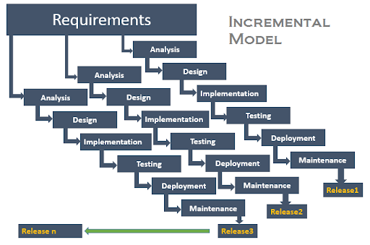utility from each build.

**Figure 1: Incremental Model**

## Rationale behind Selected Methodology

We have selected incremental model to develop the system. In this Model an overall architecture of the total system is developed first, the detailed increments and releases are planned. Each increment has its own complete life cycle. The increments may be built serially or in parallel depending on the nature of the dependencies among release and on availability of resource. Each increment adds additional or improved functionality to the system.

* It is easy to test and debug the product during iterations
* Software released in increments over time is more likely to satisfy changing user requirements than if it were planned as a single overall release at the end of the same period.

**Tools and Technologies**

**Table 1: Tools and Technologies**

We have used android studio for the application development using java language The Java Development Kit (JDK) is an implementation of either one of the Java SE, Java EE or Java ME platforms released by Oracle Corporation in the form of a binary product aimed at Java developers on Solaris, Linux, Mac OS X or Windows. The JDK includes a private JVM and a few other resources to finish the recipe to a Java Application. Since the introduction of the Java platform, it has been by far the most widely used Software Development Kit.

Table 1: Tools and Technologies

|  |  |
| --- | --- |
| **Windows 8 or higher** | Operating system |
| **MS Visio 2016** | Gantt chart, Use Case, Incremental Model Diagram,  Flowchart, Activity Diagram. |
| **MS Word 2016** | Documentation |
| **MS Power Point** | MS PowerPoint |
| **Android Studio (latest version)** | Development Tool |
| **PyCharm** | Development Tool |
| **Python** | Development Language |
| **Java** | Development Language |
| **KitKat (min)** | Android OS |
| **Firebase** | Database |

CHAPTER NO. 02

PROBLEM DEFINITION

# Problem Definition

Eventivo is a much-needed system in this busy world. Due to lack of time people face many difficulties in booking venue and other essentials for a function. This system will provide a place for users to book their requirements of function online without much headache and less time consumption. As everything these days is being online so this system will be a fruitful and beneficial addition in this online world. The user can easily check the nearby and recommended venues in a defined budget Many people want to book the venue and other essentials will less or no effort these days, but people have to visit different banquets and marquees individually and collect the quotations. Some people become much lazy that they delay the booking process because manually booking consumes too much time and effort involved. People don’t want to go out. People want easiness in their lives so we come up with the idea to ease the people and community. For the marriages and events, we must book marriage halls or marques or other lawn etc. and also need about all the essentials that are compulsory in the event like food, music band system, decoration, photography etc. so we designed a Place Booking application that provide all these services and our community will get benefit of it. The venue booking application provides user the searching facilities based on various factors. This android application will provide the functionality for searching wedding halls and marquees for the events.

## Problem Statement

The world is shifting to the online business-like websites and android applications. People most of the time use mobile phones and have it in their pockets. In this modern age everyone wants all work online by sitting at home so to book Halls, Banquets and other essentials for any event (birthday, Wedding, Engagement etc.) manually is very time-consuming task for most of the people. They have to go to collect all correct information through manual visits. Due to much time consumption in manual visits to each venue, people lower their choices and visit the main ones only and leaves the better ones just because of travelling and time consumption. There’s no system for suggestions-based recommendation in any app.

## Proposed Solution

Everything is moving towards the online business-like websites and android applications. Most of the time, people use mobile phones and have it in their pockets. Our people spend most of their time by using cellphone and scrolling their social media feed. So, this application is android based and everyone having smartphone can use this app and can avail the services. Many people do not visit all the halls and banquets to get information about these venues and finalize the near one or that looks good but, in this way, they don’t visit all halls and not have much info about all. By Using this application people will get all information about the nearby halls or anywhere they want to find can search and contact with them. It’s a great work for community without any boundary and can get complete access on food ordering, sitting capacity and all other arrangements on a single application. We can also get the profit by running ads on it and by adding Feature your venue option. We can do sentiment analysis on the base of feedbacks of people so that we can suggest venues.

## Deliverables and Development Requirements



### Hardware Requirements

* Laptop Core i5
* RAM 8 GB (min)
* HDD 500 GB (min)
* Android Cellphone

### Software Requirements

* Windows 8 or higher
* Android studio 4.0.5
* Firebase Database
* PyCharm

## Current Systems



### VenueHub.pk

VenueHub.pk is the site for booking marriage halls, lawn, marquees for party, wedding, ceremonies etc. This is very professionally developed website for bookings. It’s providing the different venues for different events and vast range of categories of events. The owner has almost all rights and access to the system as he can check about reservations, budget, employee, food quantity etc.

Review Says:

* It’s just for Lahore city
* Unable to purchase services according to your needs
* No Suggestions option

### VenuBazaar.pk

Venue Bazaar is the platform for the people where they can advertise their Venue details in reasonable price, they can upload the Venues images, Location of venue, facilities like (Music System, food etc.) and booking dates. User can also find Venues with ease by using the website, either it is for hangout or for any type of family event.

Review Says:

* It’s only providing services in Karachi city
* Not giving any option about comparison of venues
* No feedback or review option
* No e-pay option
* No category wise services option

CHAPTER NO. 03

REQUIREMENT ANALYSIS

# Requirement Analysis

In this chapter requirements analysis, feasibility study, planning, forecasting, modeling, scheduling and design of the project is discussed. For developing any project, the major problem is requirement gathering. Asking questions from clients is straightforward than collecting requirements. We will also focus on functional and non-functional requirements. The procedure for gathering requirements has its own defined procedure according to the complexity of the application. To define project schedule and processing, different models and techniques also focused on this chapter.

## Requirements Gathering Techniques

A requirement can be defined as a condition or capability that must be processed by a product or an application. Techniques that can be used for collecting requirements are as follows:

* By survey and interviews
* By observations
* Using software tools
* Using techniques for decision making
* Use of prototype

Requirements analysis is the process of planning, forecasting and studying the overall former needs of the application requirements. Requirements analysis is further divided into two parts:

1. Functional Requirements
2. Non-Functional Requirements

## Functional Requirements

Functional requirements are the requirements that should be provided by an application. It is defined as a service statement. Functional requirements tell how an application should behave in different situations and how it will react to a particular input.



**FR1-Authentication**

* A valid email and login are required to create an account
* Account will be approved by the Admin

**FR2-Venue Search**

* The system shall allow the user to search venues
* After clicking on required venue from search results, all the details of particular venue can be seen.

**FR3-Venue Suggestion**

* The system will suggest the Venues with help of NLP (semantic analysis)
* It’s depending on the previous reviews and distance

**FR4-Venue Comparison**

* The system shall allow the user to do the comparison between 2 Venues

**FR5-Chat Option**

* The system shall allow the user to chat with the manager without sharing their personal details

**FR6-Booking Essentials**

* The system shall allow the user to book the essentials whatever he/she want for the event like Dj, Food, Decoration etc.
* The system shall allow the Manager to manage and update the essential details like categories and budget etc.

**FR7-Feedback**

* The system shall allow the user to give Feedback / Ratings about the place to recommend

**FR8-Payment**

* The system shall allow the user to pay their total charges of the event

## Non-Functional Requirements

Non-Functional Requirements characterize the requirements as far as execution, plan imperatives, measures consistence, unwavering quality, accessibility, security, viability, and convey ability.



### Security Requirements

* Only authorized users can access the system.

### Maintainability

* Making changes or upgradeability in the application won't be that much troublesome. By having some information on programming, a few highlights of the application may be changed over to another adaptation.

### Availability

* The Application must be receptive and will be available each time.
* Application must be work on time efficiently.
* Application connectivity time must be good

### Performance

* This application must perform the action on time without any delay
* Over Application through an output in time
* This Application perform efficiently

### Portability

* This is android-app that is why there is no problem in portability.

### Scalability

* The System shall be able to support multiple users at a time

## Use Cases Diagram(s)

An important part of the analysis phase is to drawing the diagrams of Use cases. They are used through the phase of analysis of a project to find and divide functionality of the application. Application is separated into actors and use cases. Actors play the role that are played by the application users. Use cases define the application behavior when one of the actors sends any particular motivation. Some of the use cases are as follows



### System Level Use Case

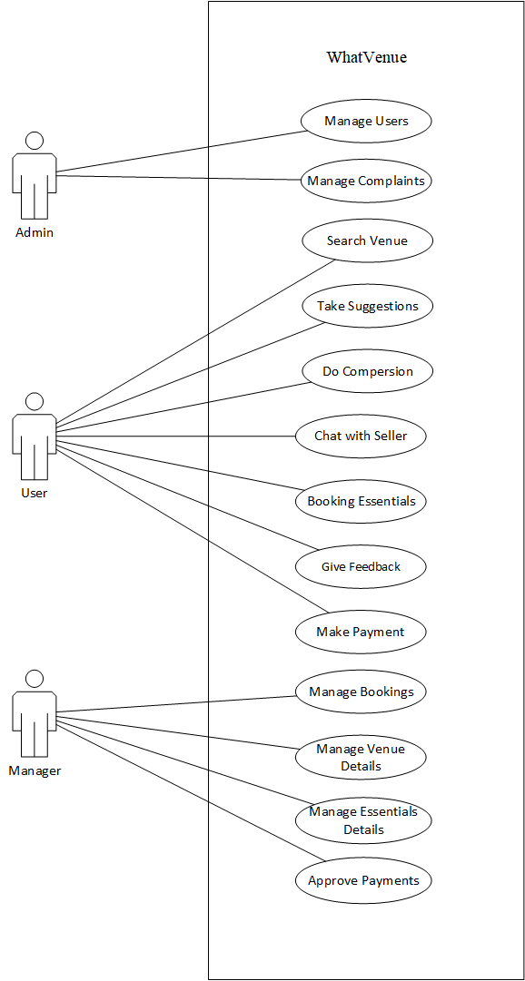

**Figure 2: System Level Use case**

Figure 3: System Level Use Case

## Use case description

**Search Venue**

Table 2: Search Venue

|  |  |
| --- | --- |
| **Use Case** | Search venue |
| **Type** | Primary |
| **Primary Actor** | User |
| **Secondary Actor** | System |
| **Description** | The user can search about the venues by adding location or application show the user nearby halls automatically |

**Take Suggestions**

Table 3: Take Suggestions

|  |  |
| --- | --- |
| **Use Case** | Take Suggestions |
| **Type** | Primary |
| **Primary Actor** | User |
| **Secondary Actor** | System |
| **Description** | The user can get suggestions from the system about the best hall for booking with respect to food and sitting. |

**Do Comparison**

Table 4: Do Comparison

|  |  |
| --- | --- |
| **Use Case** | Do Comparison |
| **Type** | Primary |
| **Primary Actor** | User |
| **Secondary Actor** | System |
| **Description** | The user can compare the different marquees or halls on the base of food and sitting criteria. |

**Chat with Seller**

Table 5: Chat with seller

|  |  |
| --- | --- |
| **Use Case** | Chat with Seller |
| **Type** | Primary |
| **Primary Actor** | User |
| **Secondary Actor** | System |
| **Description** | The system shall allow the user to chat with the manager without sharing their personal details |

**Booking Essentials**

Table 6: Book Essentials

|  |  |
| --- | --- |
| **Use Case** | Booking Essentials |
| **Type** | Primary |
| **Primary Actor** | User |
| **Secondary Actor** | System |
| **Description** | User can book the desired hall or marquee and all other essentials like Dj , Decorator etc.by clicking on booking button. |

**Feedback**

Table 7: Feedback

|  |  |
| --- | --- |
| **Use Case** | Feedback |
| **Type** | Primary |
| **Primary Actor** | User |
| **Secondary Actor** | System |
| **Description** | The user can rate or give feedback about their experiences with the specific hall so people get to know about the other people reviews about that venue. |

**Make Payment**

Table 8: Make Payment

|  |  |
| --- | --- |
| **Use Case** | Make Payment |
| **Type** | Primary |
| **Primary Actor** | User |
| **Secondary Actor** | System |
| **Description** | The user can make payment online for booking halls or other essentials |

**Manage Bookings**

Table 9: Manage Booking

|  |  |
| --- | --- |
| **Use Case** | Manage Bookings |
| **Type** | Primary |
| **Primary Actor** | Manager |
| **Secondary Actor** | System |
| **Description** | The Manager after authentication can manage all the bookings and essential services. |

**Manage Venue Details**

Table 10: Manage Venue Details

|  |  |
| --- | --- |
| **Use Case** | Manage Venue Details |
| **Type** | Primary |
| **Primary Actor** | Manager |
| **Secondary Actor** | System |
| **Description** | The Manager deals with al type of venue details like add venue, categories, food details, sitting capacity etc. |

CHAPTER NO. 04

DESIGN AND ARCHITECTURE

# Design and Architecture

In this Chapter, the details of the “**Eventivo**” system is provided. The Eventivo application provides user the searching facilities based on various factors. This android application will provide the functionality for searching wedding halls and marquees for the events.

## Architectural design:

Our project is meant to be responsive management of functions which deals with tremendous information regarding the Venue Booking system. We’ll use the Android studio for the android application and for the machine learning implementation we’ll use PyCharm and python Language Database that we’ll use be the Firebase. For the marriages and events, we must book marriage halls or marques or other lawn etc. and also need about all the essentials that are compulsory in the event like food, music band system, decoration, photography etc. so we designed Eventivo application that provide all these services and our community will get benefit of it. This application provides user the searching facilities based on various factors. This android application will provide the functionality for searching wedding halls and marquees for the events. The user has to create an account with proper authentication from email. Whenever user will open this application for the first time, he/she has to register their account themselves so that we can save their record on server side. This is the first interface of the application with which user can interact for the first time by opening application. If the user has already register on the application, he/she has to just enter the username and password. While the admins and the venue managers have to simply login the account. We have used firebase real time database for data storage and data of users and all the venues.

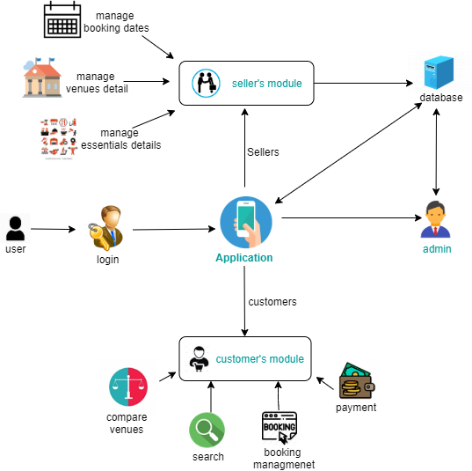

Figure 4: Architecture Diagram

## Data design

The most significant objective of this stage is to build up the application. The work in this stage must to be significantly clearer because of the work done in the arranging and configuration stages. This stage includes changing plan particulars into executable projects. At the point when the plan is there, designers can have a thought of the vibes of the application. All that is required by designers is to placed them in one spot to comprehend the expected project. Firebase Database will be used for authentication and for the data storage.

## Data dictionary

* Unified Modeling Language -UML
* Data Flow Diagram – DFD
* Graphic User Interface -GUI
* Procedural description language – PDL

## Design models

The applicable models may include:

* Activity Diagram
* Class Diagram
* Sequence Diagram
* Dataflow Diagram



### Class Diagram

The class diagram is the main building block of object-oriented modeling. It is used for general conceptual modeling of the structure of the application, and for detailed modeling translating the models into programming code. Class diagrams can also be used for data modeling.

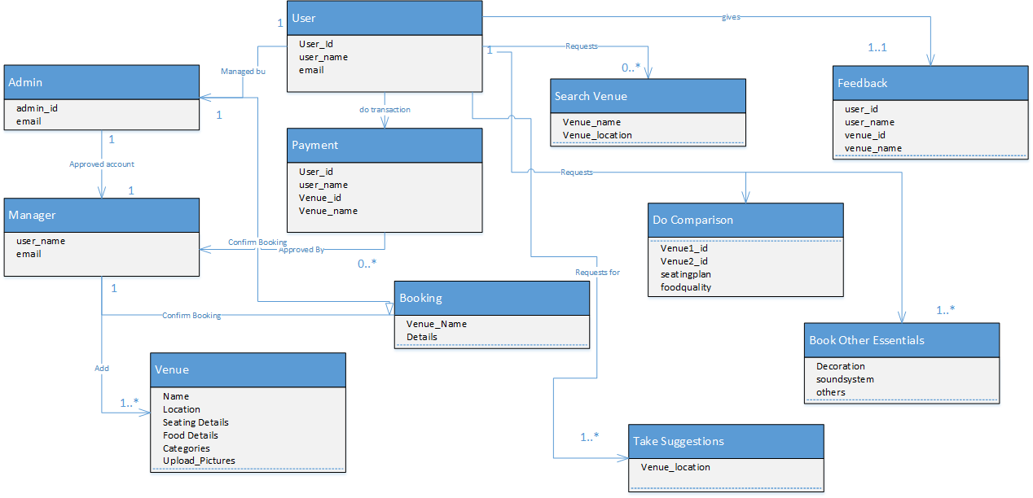

Figure 5: Class Diagram

### Sequence Diagram

**User**

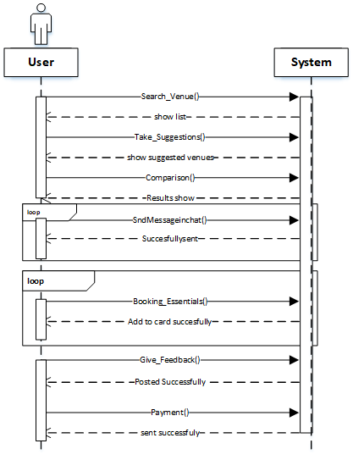

Figure 6: Sequence Diagram (User)

**Manager**

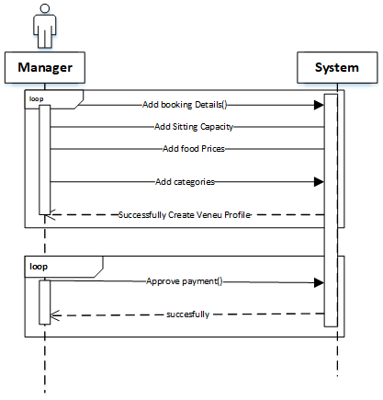

Figure 7:Sequence Diagram (Manager)

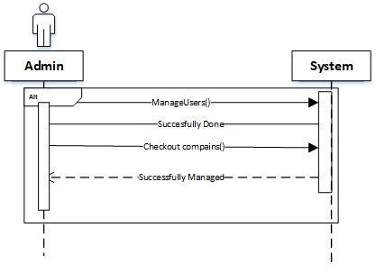**Admin**

Figure 8: Sequence Diagram (Admin)

### Activity Diagram

**User**

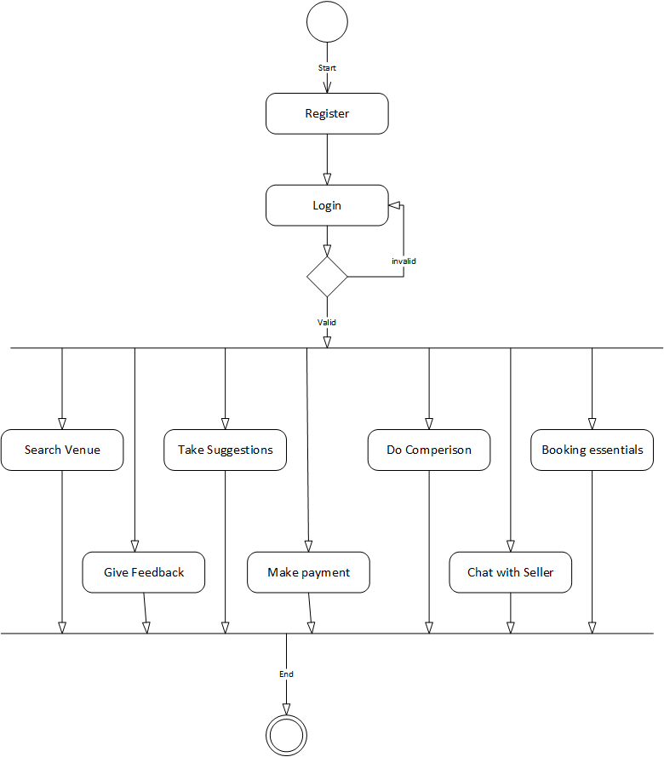

Figure 9: Activity Diagram (User)

**Manager**

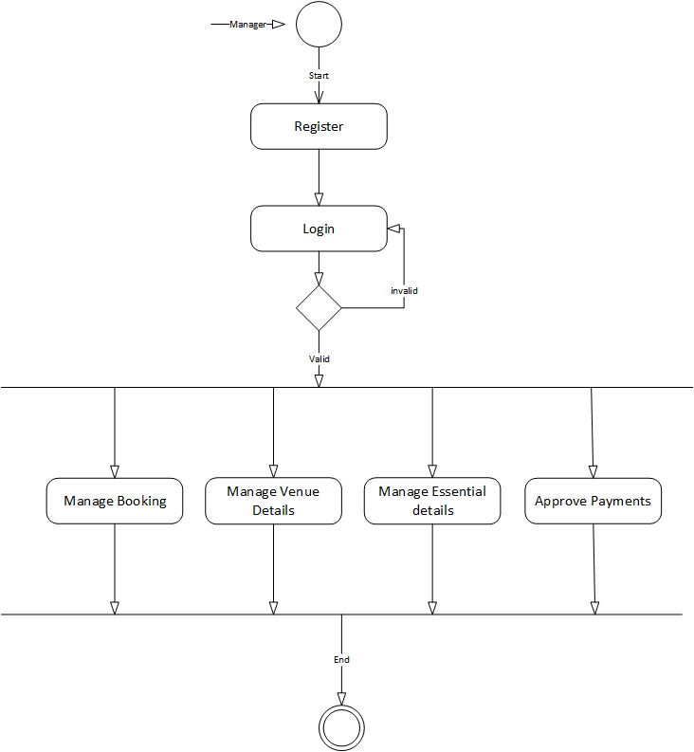

Figure 10: Activity Diagram (Manager)

### Dataflow Diagram

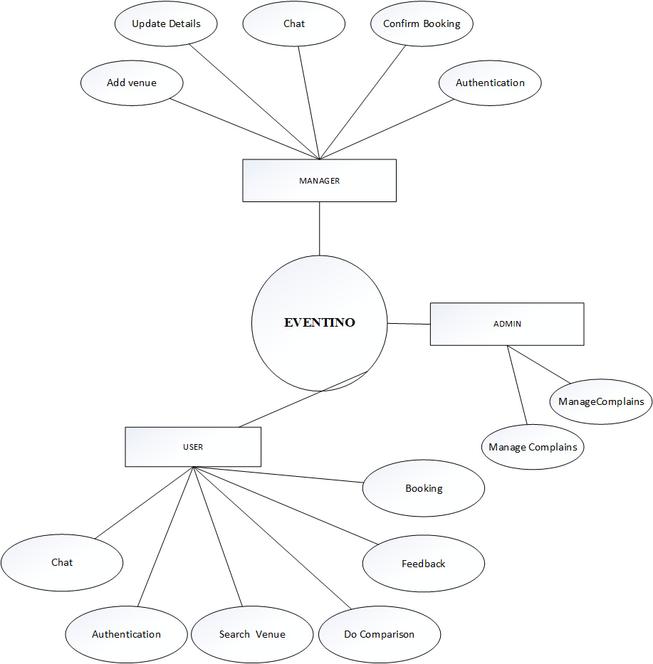

Figure 11: Data Flow Diagram

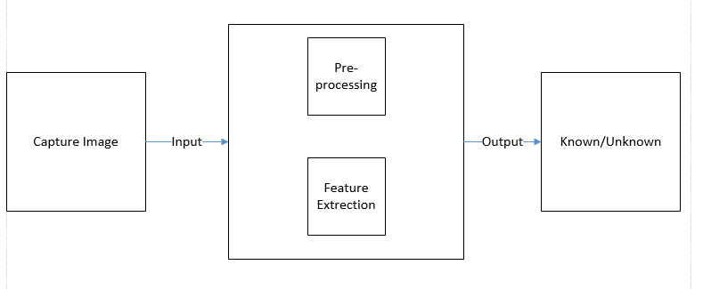

CHAPTER NO. 05

IMPLEMENTATION

# Implementation

In this chapter “Implementation” we’ll focus on the implementation of **“Eventivo” Android Application** system.

In implementation phase of this project implementation on the interface and on the backend, coding is involved. The system interface is implemented using android studio Setup while the backend components, which are database and coding, are implemented fully using java language. For the machine learning we use python language.

## Algorithm and implementation

* We will upload this project on play store so people can easily get the details about the nearby venues.
* Seller and Buyer must login to get facilitated.
* We must give an access to any administrator for administrator’s role.
* Buyer/ seller or admin can access this application with high speed internet connection and with his/her email address and password.
* Buyer can search venues and contact with sellers
* Seller can post his venue’s ads.
* Admin will manage the users and approve the ads.

## User Interface

There will be a user-friendly and responsive GUI. A user maybe a member or admin of the system. User have separate panel that is user view. A user can get access after login. The system shall allow the user to chat with the manager without sharing their personal details. The user will book all the function’s essential without any effort. User will be able to compare different venues by this online system. The system will give suggestions according to the budget and number of people. The seller will be able to get more customers by creating the venue’s profile.

**Splash Screen**

Figure 12: Splash Screen

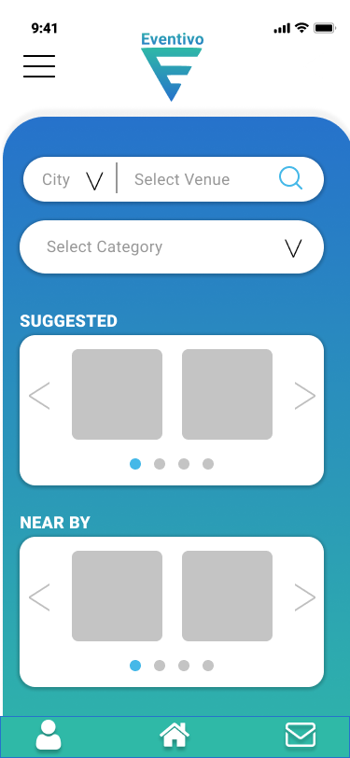**Home Screen**

Figure 13:Home Screen

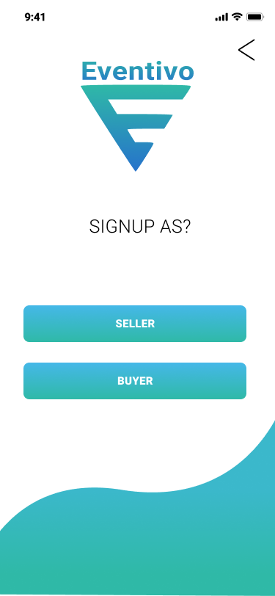**Sign Up Screen**

Figure 14: Sign Up

**Sign in Screen**

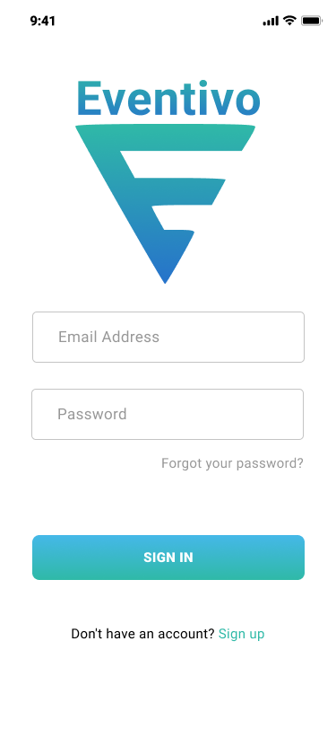

Figure 15: Sign in

**Add Venue**

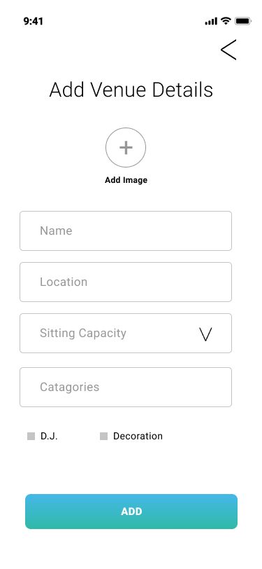

Figure 16: Add Venue

**Manage Essentials**

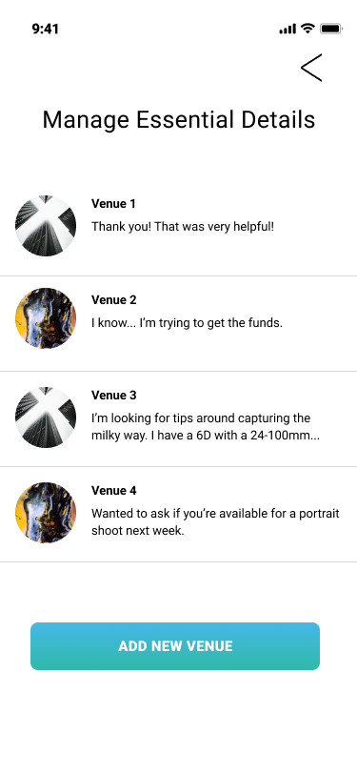

Figure 17:Manage essentials

CHAPTER NO. 06

TESTING AND EVALUATION

# Testing and Evaluation

This chapter will describe about testing and evaluation of the project. In this, we are required to perform the testing both manually and automated.

## Manual Testing

 Manual Testing is a process of finding out the defects, bugs in a software program and this testing verifies if all the features are working properly or not. Tester manually executes the test cases. Manual testing is the process of using the features of an application as an end-user. Considering the scope of the project and the time limitations, we will be performing following tests.

1. **Unit Testing:**

This testing verifies the program logic and verifies program structure

**Unit Testing 1:** Login as User

**Testing Objective:** To ensure that the login module of the application is working correctly

**Table 11: Unit Testing 1**

|  |  |  |  |  |
| --- | --- | --- | --- | --- |
| No | **Test case/Test script** | **Attribute and Value** | **Expected result** | **Result** |
| 1 | Verify user login after click on the „Login‟ button on login form with correct input data | Email  waheed@gmail.com  Password  12345678 | Successfully log into the Home page of the system | Successfully Logged in |
| 2 | Verify user login after click on the “Login” button | Email  waheed@gmail.com  Password  12345678 | Password should be at least 8 character | Passed |

**Unit Testing 2**: User and Manager Account Registration

**Testing Objective:** To ensure the Manager and User registration is working properly

**Table 12: Unit Testing 2**

|  |  |  |  |  |
| --- | --- | --- | --- | --- |
| No | **Test case/Test script** | **Attribute and Value** | **Expected result** | **Result** |
| 1 | **User** registration with all required correct inputs | Email  waheed@gmail.com  Password  12345678 | Provided data is correct | User registered successfully |
| 2 | **Manager** registration with all required correct inputs | Email  waheed@gmail.com  Password  12345678 | Provided data is correct | User registered successfully |

**Unit Testing 3**: Add Venue

**Testing Objective:** To ensure that the register lost person complain working properly

**Table 13: Unit Testing 3**

|  |  |  |  |  |
| --- | --- | --- | --- | --- |
| No | **Test case/Test script** | **Attribute and Value** | **Expected result** | **Result** |
| 1 | Manager will add venue by getting login into the app | Email  waheed@gmail.com  Password  12345678 | Provided data is correct | User login successfully |
| 2 | Manager add venue | Venue Name  Location  Charges  Area  Seating Capacity | Provided data is correct | Successfully Added new Venue |

**Unit Testing 4**: Admin Module

**Testing Objective:** To ensure that the register lost person complain working properly

**Table 14:Unit Testing 4**

|  |  |  |  |  |
| --- | --- | --- | --- | --- |
| No | **Test case/Test script** | **Attribute and Value** | **Expected result** | **Result** |
| 1 | Admin get login into the system | Email  Admin@gmail.com  Password  12345678 | Provided data is correct | Admin login successfully |
| 2 | Approve Venue | Approve / Reject | Provided data is correct | Successfully Approved |

1. **Functional Testing**

The functional testing will take place after the unit testing. In this functional testing, the functionality of each of the module is tested. This is to ensure that the system produced meets the specifications and requirements.

**Functional Testing 1:** Login with different roles

**Functional testing Objective**: To ensure that the correct page with the correct navigation bar is loaded.

**Table 15:Functional Testing 1**

|  |  |  |  |  |
| --- | --- | --- | --- | --- |
| No | **Test case/Test script** | **Attribute and Value** | **Expected result** | **Result** |
| 1 | Verify user login after click on the „Login‟ button on login form with correct input data | Username: test@gmail  Password: 123456 | Successfully log into the Eventivo App by registering a new account | Successfully Logged in |
| 2 | Verify Manager login after click on the “Login” button | Username: manager@gmail  Password: 123456 | Successfully log into the Application | Successfully Logged in |

CHAPTER NO. 07

CONCLUSION AND FUTURE WORK

# Conclusion and Future Work

This chapter concludes the project and highlights future work.

## Conclusion

We’ve successfully developed the Eventivo Application where you can get all information and can booked the required hall, Marquee or the place where you want to be done your event. This app provides the suggestion option to the users according to the base of the feedback on the bookings by the users. User can book hall or place according to the event and can give feedback after successful event. It’s a great application to help out the people of our country.

## Future Work

* In the future this app will be developed for iOS.
* We can add calling function directly from the app and can add option for fix a meeting time with the Venue Manager.

# References

1. Soleh, O., Ariessanti, H. D., & Haryono, G. F. (2017, October). Wedding innovative application as a container to provide wedding preparation service: Development and application. In 2017 International Seminar on Application for Technology of Information and Communication (iSemantic) (pp. 121-125). IEEE.
2. Kumar, A., & Jain, R. (2015, October). Sentiment analysis and feedback evaluation. In 2015 IEEE 3rd International Conference on MOOCs, Innovation and Technology in Education (MITE) (pp. 433-436). IEEE.
3. Rogerson, J. M., & Wolfaardt, Z. (2016). Wedding tourism in South Africa: An exploratory analysis.
4. Farooq Butt, H., Akhtar, F., & Shaukat, T. (2017). Online Wedding Arrangement (Doctoral dissertation, University of Management and Technology).
5. Booth, J. R. (2010). U.S. Patent No. 7,725,402. Washington, DC: U.S. Patent and Trademark Office.